Instructor Resources

Kidovate Youth Entrepreneurship Experience

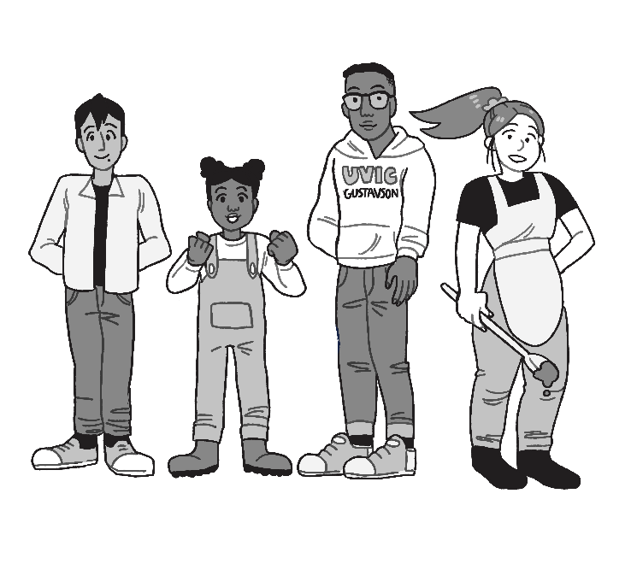

Dr. Brock Smith
Peter B. Gustavson School of Business
University of Victoria

Instructor Resources

Kidovate Youth Entrepreneurship Experience

Many countries, including the USA, France, and Austria have made youth entrepreneurship a strategic priority because entrepreneurship is the economic engine that produces national wealth, prosperity, and quality of life. Entrepreneurs are change agents who identify and realize opportunities to create new value in business, government, social, and other organizational and new venture contexts. Deliberate practice is the best way to develop the skills and acumen needed for entrepreneurial success, and early entrepreneurial experiences are critical to developing the needed entrepreneurial mindset.
An entrepreneurial mindset provides youth with the skills to adapt to a changing world, helping them learn to take initiative, meet challenges, and become financially independent architects of their own future. These attributes are fundamental to positive mental health. Providing youth with a foundation for developing this mindset will help increase the number of successful adult entrepreneurs who will improve the lives of others through invention, innovation, initiative development, and other forms of value creation.
Kidovate Victoria is a fun, free, hands-on youth entrepreneurship initiative that uses a community partnership model to foster grassroots entrepreneurial spirit, develop core business acumen, and instill the concept of corporate social responsibility among middle school and high school students. Developed by the Gustavson School of Business at the University of Victoria, this initiative encourages students to make and sell products at a Kidovate market stall, or from their own stand, on Kidovate Market Day. ^{h}.
The educational materials provided herein, are for teachers, home school parents, after school program coordinators, youth group leaders, or engaged parents who want to support youth in entrepreneurial pursuits. They complement a graphic novel style Kidovate workbook that walks youth through key business decisions associated with starting a micro business (found on the Kidovate website: www.Kidovate.ca). Three lessons with hands-on learning activities are provided in this document. For free access to the other 11 lessons, please email Dr. Brock Smith at the University of Victoria (smithb@uvic.ca). The lessons and activities are intended to provide more depth to entrepreneurship learning than is provided in the youth workbook.

Table of Contents

ENTREPRENEURSHIP Unit 1: Coming Up With the Idea 1
Lesson 1.1: So You Want To Be An Entrepreneur 1
Lesson 1.2: Where Do New Product Ideas Come From? 7
Lesson 1.3: Turning New Product Ideas into Product Concepts 14
Unit 1 Assignment: Elevator Pitch or Written Product Concept 21
ENTREPRENEURSHIP Unit 2: Proof of Concept 23
Lesson 2.1: Market Validation 23
Lesson 2.2: Product Validation & Prototyping 28
Lesson 2.3: Financial Validation 31
Unit 2 Assignment: Proof of Concept Presentation 35
ENTREPRENEURSHIP Unit 3: Business & Marketing Strategy 36
Lesson 3.1: Making Pricing Decisions 37
Lesson 3.2: Making Distribution Decisions 39
Lesson 3.3: Effective Marketing Communications 41
Lesson 3.4: Personal Selling / Sales Pitch 45
Lesson 3.5: Merchandizing 49
Unit 3 Assignment: Presenting Your Sales Pitch 50

ENTREPRENEURSHIP Unit 1: Coming Up With the Idea
All organizations need to innovate to survive. Business organizations need to develop new products (goods, services, experiences, or performances) to stay competitive. Entrepreneurs develop these new products. Sometimes they create new businesses around those new products.

Lesson 1.1: So You Want To Be An Entrepreneur

This lesson has three components:
- What is Entrepreneurship?
- What Entrepreneurs do: creating new value.
- Why Youth Should Learn Entrepreneurship Skills

Lesson 1.1.1 - Content for Teachers: What is Entrepreneurship?

The word entrepreneur describes many different kinds of people doing many different kinds activities. The word, for example, describes serial entrepreneurs or repeat entrepreneurs, people like Richard Branson (Virgin Group) who start many businesses in many different industries (Virgin Airlines, Virgin Records, Virgin Intergalactic). But the word entrepreneur is also used to describe the person who owns and operates a corner store, or the person who owns, but perhaps does not actually operate, a McDonald’s franchise, or the person who makes and sells jewellery on e-commerce websites such as Etsy.
So what is entrepreneurship? For some people, entrepreneurship is the act of creating a new business venture. We (and many others) define entrepreneurship more broadly, as the act of creating new value. People create new value in schools – such as recycling programs or anti-bullying initiatives. People create new value in government, such as building highways or bridges that help people travel more effectively, building a new school in regions growing with young families, or providing social services to help people who need assistance. Whenever something new is created and either sold or provided to customers, someone had to come up with the idea, marshal resources and approvals to make it happen, and put a team together to get it done. These change agents are entrepreneurs, because they do the same things as other entrepreneurs, they just don’t create a new organization to do them. So what do these examples have in common?
ENTREPRENEURS:
- Identify opportunities to create something new that is valuable to others
- Figure out the arrangements, approvals, and support to make it possible
- Create it, make it, and coordinates or facilitates it being made or created
- Finds a way to get it into the hands (minds, bodies) of customers, users, or adopters.

ACTIVITY 1.1.1: Concept Map: What is Entrepreneurship & Who Are Entrepreneurs?

Ask your class:
What does the word Entrepreneur mean to you? (if they have internet access they could do some inquiry). You could also ask if students know anyone who is an entrepreneur. What do they do?
Task:
- Individually, write down 5 - 10 words that you associate with the word entrepreneur? These words could relate to your understanding of: (3 or 4 minutes)
- The definition of entrepreneur
- What entrepreneurs do
- Words you think are associated with the word entrepreneur
- In groups of 4 students, ask the students to compare their words and to categorize them by theme. Have them report back on their themes with examples of some words for each theme. (10 minutes)
- Have the class discuss the similarities and differences between the groups.
Learning Insight:
Class examples could include:
- Make and sell things: products, goods, services, salesperson
- Run a business: owner, operator, manager, planner, strategy
- Create a new business: new venture
- Invents new products: innovator, invention, coordination, technology, circumstance
- Employs others: hires, fires, pay, motivates, leader
- Makes money: profit, income, revenue, expenses.
Depending on the age of your students, you might get negative associations raised: e.g., Exploits workers, greedy, pollutes). Here you might add perspective on themes that are off-track or might have multiple perspectives (e.g., entrepreneurs are not evil, but some entrepreneurs might make choices that others consider to be poor, such as cutting down trees or harvesting fish).
Depending on the age of the students, you might start with a discussion of what is a business and what is the difference between a large business and a small business. After discussion about a business organization, have students turn to a partner and talk about the difference between people who are business people and people who are entrepreneurs. Share thoughts with class.
Entrepreneurs are people who create new value. Key skills entrepreneurs learn are:
- opportunity recognition (identification),
- creating or designing solutions
- attracting the resources and permissions to create the new product (new good, service, experience, initiative, or performance)
- developing systems or approaches to making and selling the product, or getting it used or adopted, at a profit.

Lesson 1.1.2 - Content for Teachers: What Entrepreneurs Do - Creating New Value

Entrepreneurs create new products that are valuable to others. Products can be physical goods, such as a bracelet, a painting, or a cookie. Products can be services (activities you do for, or to, others), such as mowing lawns, pet sitting, hair cutting, or helping people figure out how to use their computers or phones. Products can also be experiences, such as performances, a guided tour, or other interactions with people, nature, or technology. Social entrepreneurs create new programs, initiatives, or activities that change social behavior, such orange shirt day to raise awareness of indigenous issues.
The main difference between social entrepreneurs and other entrepreneurs is that for social entrepreneurs the users or adopters of the new thinking, or system, are typically not the ones directly paying for it (often it is government or donor funded). For other entrepreneurs the customers (the users or adopters) are typically the people who pay for the goods or services. We use the term “product” to mean anything of value that can be exchanged with, or adopted by, others.
The key essence of entrepreneurship is new value creation. But what do we mean by new? Entrepreneurs are the people who create the first transaction or exchange (they sell new products to existing customers, existing products to new customers, or new product to new customers).
Management is about selling more of existing product to existing customers. What is new can be considered on a continuum, ranging from new to you (which is not very valuable to others), to new to some people in your community, new to your region, new to the country, or new to the world. New to the world innovations are rare.
This range can also be from small improvements (incremental innovation) such as new flavours, a faster computer processor, or a better camera in your phone, to new to the world (radical) innovations, such as the first digital camera). Most entrepreneurs create new value by making small improvements or changes, such as offering something that already exists some other place, to customers a new place, or improving something that already exists here.

ACTIVITY 1.1.2: Thought Exercise: What is Valuable?

Ask your class:
If the essence of entrepreneurship is creating new value, what is value? What are some products (physical goods, services, or experiences) that you like and why do you like them? What do they do for you? What are their benefits?
Task:
- Work with a partner to identify one physical product that you like and one service or experience that you like. Write down what you like about them. What do they do for you? Why are they worth the money that you have to pay for them?

Physical Good: ___________________
Service or Experience: _________________
Why they are valuable to me (why I like them)
________________________
________________________
________________________
________________________
________________________
________________________

- Have the students report their examples.

- Organize their thinking on a blackboard / whiteboard into four categories: four types of value (with examples)
Useful/Performance Sensory/emotional Symbolic/Meaning Cost/Sacrifice
(Utilitarian) / Relational (Hedonic)
- Works better - smells good - trendy - cheaper
- Does the job well - tastes good - be popular - good deal
- Faster - feels good - fit in - convenient
- Stronger - pleasurable - show off - simple
- More reliable - scary - status - easy to use
- Fits better - closer - prestige - not frustrating
- - be together - frugal - timely
- - share - environment conscious
- - be closer

Learning Insight:
Entrepreneurs create four types of value, in different ways and in different combinations. Benefits are another word for value (or entrepreneurs create value and customers perceive benefits – two sides of the same coin). Customers buy benefits not features. Features are what it is, functions are what it does, and benefits are why customers care. Consider a bottle of pop with a plastic lid. One feature is a twist cap. The function of the twist cap is it allows the bottle to be re-sealed. The benefit to the customer is they don’t have to drink the entire beverage all at once (and it does not spill). The most important lesson in entrepreneurship is to offer something that at least some people want, that is unique in a way the customers’ value. If everyone sold the same type of cookies, not many cookies would be sold by any of the cookie entrepreneurs. When customers have a choice and businesses offer something different from each other, each business can prosper.
Organizations that create different types of value (well), tend to do better than organizations that only create one type of value. The typology above is useful as it helps you answer the question: How could you add value to your new product?

Lesson 1.1.3 - Content for Teachers: Why Entrepreneurship?

Entrepreneurship is how new products are created for adoption or consumption by society. It is the economic engine that enables human progress. That is because entrepreneurship provides incentives and rewards for people to innovate – it puts money in their pockets and bank accounts – if they can make and sell something to others and a price that is higher than the cost of making and selling it. Entrepreneurship is not particularly rare or special – it happens all the time, by millions of people, all over the world. For every store, restaurant, or sales website you have ever been to, or seen, there was an original entrepreneur who created it.
It is human nature for people to want to improve their situation, and entrepreneurship is the means by which people make money (or create social value) for making those improvements for others. Although not rare or special, entrepreneurship is a skill, and some people do it a lot better than others do.
Youth can learn entrepreneurial skills so they can be people who grow up to improve the lives of others by creating goods, services, or social initiatives that improve society. Education and practice is the best way to develop skill in entrepreneurship. The earlier youth start to learn and practice, the better they will get at doing it. That is why we encourage youth to participate in Kidovate, this year, and in years to come. The experience gained and skills learned from creating a very small business will help them in the future if they ever decide to start a business that has potential to grow to be a large business. Operating their own business in the future means that they are not dependent on others to provide work and money. Even if youth are not interested in operating their own business in the future, entrepreneurship skills are useful in any career endeavor. All organizations need to innovate to stay competitive, and they want to hire people who can create new value within those organizations. Skills in entrepreneurship will help youth in getting the job and career that they want. But for now, right now, entrepreneurship is also one way to put money in their own pocket or bank account, and Kidovate can help them learn how to do that.
Kidovate is a youth entrepreneurship initiative that encourages middle school and high school students to make something to sell at a Kidovate market, or at their own booth, table, or stall, on the third Saturday in May (May 25th this year). To help them do that, we have created a graphic novel workbook that follows the thinking of two young entrepreneurs as they decide what to make and sell and how to make and sell it. This graphic novel is available for free download from the Kidovate website (www.Kidovate.ca). In addition, there are other useful resources on that website for youth and teachers. Youth, for example, can find coupons for local retailers to lower the cost of buying materials for the product they decide to make. When they register for Kidovate (free) they will be issued a business license. Business licenses are required to operate a business, and typically cost in the range of $150 per year. Youth must display the free, one-day, Kidovate license at their booth, table, or stall on the Kidovate market day so by-law enforcement officers know they are part of the Kidovate initiative. The Kidovate team is organizing marketplaces at local mall locations (see website), but youth can also set up a table in their own neighborhood (not at public parks). The Kidovate team is working with local media to prime customers to look for Kidovate booths and tables and stop to see what youth are selling. Making the sale is up to them!
An entrepreneurial mindset provides youth with the skills to adapt to a changing world, helping them learn to take initiative, meet challenges, and become financially independent architects of their own future. These attributes are fundamental to positive mental health. Kidovate fosters social connectedness through youth interacting with adults, as equals, in a buyer-seller relationship, and by being part of a shared social experience with other youth. It encourages youth to create something valuable to others, and drive that activity themselves. They can focus on something they like or are passionate about – their choice. They can earn their own money – giving them more control on how it is spent. And they can make a contribution to their community – making them feel positive about themselves.

ACTIVITY 1.1.3: Inquiry

Can youth be entrepreneurs? What are some examples of successful entrepreneurs under the age of 18. Can you find examples of successful entrepreneurs under the age of 14?
Task:
Search the internet for example of young entrepreneurs. What was the product (good, service, experience, performance) that they created? Why is it valuable to the intended customer?
Example:
The 9 Most Successful Teen Entrepreneurs in the World (2018) https://www.careeraddict.com/teen-entrepreneurs
Mikaila Ulmer: In 2015, when she was just 9 years old, she created bottled lemonade and signed (with parental assistance) an $11 million distribution deal with US supermarket giant Whole Foods Market.
Noa Mintz; she founded the matchmaking childcare service Nannies by Noa when she was just 12 years old.
Rachel Zietz: A company CEO at the age of 13 and a self-made millionaire by 15, through her hugely successful online sportswear company Gladiator Lacrosse.

Lesson 1.2: Where Do New Product Ideas Come From?

This lesson has two components:
- Using creativity tools to generate new product ideas
- Other sources of ideas

Lesson 1.2.1 - Content for Teachers: Creativity Tools

Creativity is important. A recent survey of Fortune 500 CEO’s identified creativity skills as one of the top attributes looked for in hiring senior executives. Creativity of youth in the United States has been measured, since the mid 1950’s, by the Torrance Test of Creativity. Creativity scores of youth in the United States steadily increased from the mid 1950’s to 1990 and have been declining ever since. What happened? Many point the blame to video games, internet, steaming video and phone apps that have made youth passive receivers of entertainment. Why is this a problem? Global wealth is a U shaped curve, with income on the y axis and value chain activities on the x axis. Key value chain activities are product innovation, manufacturing, and sales. The people who create wealth are the people who come up with new products and the people who sell them. The people who make those products do not receive much of the wealth generated by the innovation. Canada’s economy is based mainly on resource extraction, but it is also based on creating new products and selling them. If creativity is decreasing, so is our ability create wealth as a nation that supports our way of life.
New product ideas often come from creative minds. Creativity is the use of imagination or original thought to create something new. Creativity is important in business because it can help entrepreneurs generate new solutions to customer problems. Creative thinking helps businesses solve customer problems better than competitors. As applied to new product development, creativity has three key elements: 1) the idea is new (novel or unique in some way), 2) it is valuable (others want it), and 3) it is commercializable (it can be made and sold at a profit). When using creativity tools to generate new ideas to solve customer problems we typically focus on the first two criteria (new and valuable). Assessment of whether the new solution can be made and sold comes later, after more thinking and research has been done. Initially, the assessment of value is simple, can we think of a group of people who might possibly pay for what we have created?
The Torrance Test of Creativity measures different dimensions of creativity.
- Fluency (or Fluidity): The number of ideas generated in response to the stimulus in a particular period of time.
- Flexibility. The number of different categories or domains of relevant responses.
- Originality. The statistical rarity of the responses.
- Elaboration. The amount of detail in the responses.

There is a simple exercise you can do with your class to help them self-assess their base rate of creative thinking (see Activity 2.1.2). Everyone has a different base rate for creative ability. However, because creativity is a cognitive skill, it can be learned, and we can train our brains to be more creative, no matter what our starting point is.
http://home.iitk.ac.in/~sahus/se367/project/TTCT.pdf
Learning Insight
The Torrance tests show that creativity scores of 12 year olds steadily increased from 1950 to 1990 and have steadily decreased thereafter. Most researchers point to technology changes that increased passive entertainment – kids don’t have the same opportunities to be creative – parents don’t send them outside anymore for 3 or 4 hours where they used to have to entertain themselves by creating activities and games.
Why does that matter? The people who create wealth for our country (and themselves) are the people who come up with new products and the people who sell them. Canada’s economy is based mainly on resource extraction, but it is also based on creating new products and selling them. If creativity is decreasing, so is our ability create wealth as a nation that supports our way of life. That is why we need more entrepreneurs.

ACTIVITY 1.2.1a: Creativity Warm Up Exercise

Task (3 minutes):
Ask your students to take out a piece of paper. On one side of the paper, ask them “what day is it today?” Give them 30 seconds or so to write their answer. Ask them turn their paper over and explain why. Why is today the day they think it is?
Collect their anonymous answers. Scan them all looking for creative answers – any answer that is not the conventional answer of the date or day of the week. Read out 10 or so conventional answers, and any creative answers. Ask the class why there were so many conventional answers and so few unconventional ones. Explain the importance of letting go of convention and give them permission to think differently than others.
So set the ground rules for the next set of activities – novel, unexpected, potentially crazy ideas are welcome and encouraged in this lesson and there will be no laughing or teasing people who provide creative thoughts. If everyone thinks the same way, there will be no innovation solutions to customer/client/society problems.
Learning Insight:
By the time students get to University 95% of them will answer the first question with the day of the week, or the date, and then answer the second question with an explanation on the back that refers to calendar origins, societal conventions, or what their phone told them. About 5% will give a creative (non conventional) answer, such as “today is the day I have coffee with a new friend” or “today is a happy day”. Why such a low level of creative answers? Because since kindergarten they have been conditioned to provide the socially safe answer, the expected answer. The problem with that, however, is that if we want novel solutions to problems, we want people to think differently from everyone else in the room, and perhaps everyone else in the planet. So we have to give students permission to think differently and provide a safe environment where they can express different thoughts.

ACTIVITY 1.2.1b: Creative Fluidity
The image below is from the Torrance Test of Creativity.
Task (5 minutes):
- Take out a blank piece of paper and a pencil
- I am going to show you an image. In one minute write down your ideas of what this image could represent. Think of as many ideas as possible.
- Show Image for 1 minute
- After pencils are down, ask the students to:
  - Count the total number of ideas they generated.
    - By show of hands find out how many students thought of 2 or more ideas, 4 or more, 6 or more, etc, until there are only a few hands showing
    - How many ideas they generated is a measure of fluidity.
  - Ask all students to share one of their ideas, and go around the room once.
    - The variation in the categories or domains of the ideas is a measure of flexibility. Some common categories are: nature, space, maps/direction.

ACTIVITY 1.2.1c: Creativity Tools – Strategic Combination

There are many tools for training brains to be more creative. One of these tools is strategic combinations. This tool uses dice to smash together words, which otherwise might not be considered together. Consideration of those words in a specific industry context can often generate innovative new product ideas.
Task (20 minutes):
- Choose an industry context that everyone in the class will have some familiarity. This could be something like apps for a phone, food, or board games.
- Generate a list of 6 words (ask the students for the words) for each of three categories that are only tangentially (not directly) relate to your industry context. For simplicity you could just use the categories: Action, Feelings, Object.

ACTION FEELING OBJECT

1. Fight Joy Phone
2. Play Victorious Gold
3. Jump Revenge Tree
4.
5.
6.

It does not really matter what these words are, but it is better if the words are not too closely related. For example happy and sad are opposites so it is better to not have both on the list. Happy and Joy are also quite similar.

- Assign one die to each category (having different coloured dice helps)
- Have students roll the dice to generate the three words that they are going to think of together and apply to the chosen industry context. In a minute or two of consideration what new product might relate to those words? The words don’t have to be taken literally, they are just stimulus for creative thought. For example, a grade 6 student was tasked with developing ideas for a new snack food. His words were Play, Victorious, Gold. The idea that he came up with was anagram chocolate bars. Each square would have a different letter. Kids would play with the chocolate squares to create as many words as possible and enter those words on a website to have a chance of winning prizes. In this case “Gold” was interpreted as prizes.
- If they can’t think a new product idea after a minute or two with their words, have them shake again to get new word combinations. If they do come up with a new product idea, have them shake again to generate more ideas.
- After 10 minutes or so, have the class report their new product ideas. We are not evaluating the ideas at this stage so don’t comment on them as being good or bad. There could be a kernel of a very good idea in one that does not seem feasible or plausible at first. You will find that lots of potentially interesting ideas get generated.
Learning Insight:
Evaluation impedes creativity at this point. It does not matter if the product already exists, or is not technologically or otherwise feasible. Students will learn how to evaluate their ideas in another lesson. If you have time, and once many ideas are on the board, you might ask the class to think of ways to modify the initial ideas to improve them.
Possible Assignment: Idea Journal
The more ideas a student generates, the more likely they are to find a very good new product idea. Ask your students to keep an idea journal for two weeks. Each day they should identify one potential new product idea (see sources of ideas) and write a three or four sentence description of that idea, specifying: what it is, what it does, how, for who, and why it is valuable/needed. At the end of the journal, ask them to reflect on their idea generation process. What process did they use and how well did it work? How might their process be improved? What approaches or tools worked or did not work for them?

Lesson 1.2.2 - Content for Teachers: Sources of Ideas

Not everyone is able to use their own creativity to identity new product opportunities. Where else do new product ideas come from? There are lots of sources, but the main sources of ideas are:
- Your own frustrations, problems, annoyances (or those of friends and family). Many people come up with their own solutions to problems they face and find that others have similar problems. For example, two local rugby players didn’t like practicing in rainy Victoria with soggy cleats. They invented Dry Feet – a soccer boot / cleat cover that keeps your feet dry.
- Customer frustrations, problems, annoyances, complaints. Listen to your existing customers, they will tell you what they want improved in the products they use, or what they think is missing in the marketplace.
- Societal problems, such as lack of affordable housing, access to clean drinking water, and global warming. Big problems need innovative solutions.
- Products that exist elsewhere but not in your community, city, province, or country. There are websites like www.Springwise.Com and blogs that profile cool new products around the world. Entrepreneurship magazines like Fast Company profile entrepreneurs and their products. Newspapers often have profiles of successful entrepreneurs and their products. When traveling you can observe new products that you can’t find at home.
- Invention. The application of scientific inquiry to solve customer or societal problems. For example, wireless printing or self-driving cars.
- Innovation. The application of scientific inquiry to address excess supply problems – such as what to do with all the materials that get picked up by blue box recycling programs. E.g., turn plastic into polar fleece, turn sawdust into MDF board. Currently the CRD is wondering what do with all of the glass that gets turned in.
- Coordination. Putting together existing products (goods or services) in a new way – such as Tea and Popsicles into Teapops – a product created by DeeBees Organics, a Victoria based company. Or facilitating the interaction of customers and products in a new way – such as EBAY or Used Victoria which make it easier for people with items to sell to find customers willing to pay for those items.
- Observation. Identifying what is missing from a marketplace. New Victoria resident Peter Gustavson wondered where visitors to Victoria exchanged their currency. The Tourism Information Centre that is downtown didn’t have a good answer so he started a currency exchange business across the street from the Tourism Information Centre. He grew that business to one of the largest currency exchange companies in the world. Observation includes deep understanding of an industry or a technology that enables people can see what is currently missing, or where technology is heading. Many new products come from deep understanding of hobbies.
- Other Entrepreneurs. Entrepreneurs are always thinking about new product ideas. They often do not have the time or energy to pursue them all. Many are happy to share ideas with young entrepreneurs.
- Creative Minds. Sometimes people come up with great new product ideas, seemingly out of the blue. Pure “Eureka” moments are rare. There are tools and techniques to help you generate new product ideas from your own mind.

ACTIVITY 1.2.2: Problems or Frustrations as Sources of Ideas

A key source of new product ideas is solving the problems, challenges, or frustrations that people face. We want to find problems that are real to a group of customers (not just our perspective), are important to them, and where they are motivated and willing to pay to solve the problem.

Task (20 minutes):
- With a partner, or in a small group, generate a list of problems, challenges, or frustrations that you or people you know, experience.
- With your partner/group, choose one problems to consider in more detail:
  - Complete the Customer Problem Cloud in as much detail as possible (see handout and next overhead)
  - How many people do you think have this problem?
- Share your customer problem insights with the rest of the class.
- Debrief: Which problems do you think would be easiest to solve? How might the evidence be found or collected to demonstrate that the problem is real, important, and motivating?
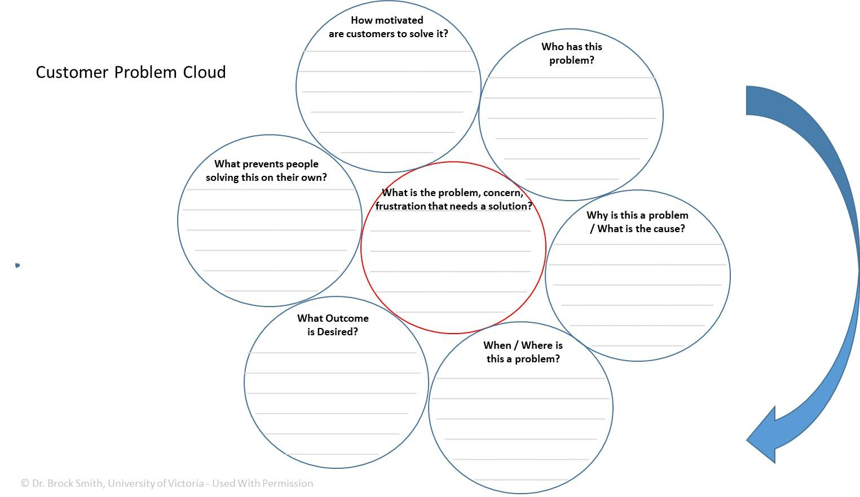

Lesson 1.3: Turning New Product Ideas into Product Concepts

This lesson has two related components:
- What is the difference between a new product idea and a product concept?
- What criteria should be used to initially screen ideas?
Content for Teachers
Basics:
Product concepts are new product ideas that have been refined, or polished, with a bit of thinking. This thinking focuses on:
- Specifying the Target Customer & Their Problem
  - To what extent is the target customer clearly identified?
  - To what extent is the target customer’s problem (desired outcome and pain point) understood?
  - To what extent is that problem real, important, and motivating the customer?
- Clearly Articulating the Solution (the new product opportunity)
  - What are the key product features, attributes, or characteristics that help address, solve or mitigate the target customer’s problem/pain?
  - What are the benefits of these features, attributes, or characteristics to the customer?
  - What are the reasons to believe that the new product will deliver these benefits?
    - Why is this technologically or otherwise feasible?
    - Why it can it be done well by this entrepreneur or team?
  - What is the dramatic difference (what makes it better than alternatives, at least in the minds of the target customers)?
Advanced:
It is important to be clear on who you think is going to purchase (or use/adopt) your new product. Very few (if any) products have universal appeal. Even Coke has detractors who prefer Pepsi. How can we describe the group of people who would be most interested in what we are offering? Marketers put descriptive labels on market segments (the different groups of customers who are interested in different solutions to their problems – e.g., Yuppies, Boomers, Granolas). At this point, we just want the student to recognize that not everyone will be interested in their new product and they need to specify or describe, in some way, the people who would be most interested in what they plan to make and sell. In common vernacular, that is the “low hanging fruit” – who are the people most interested or most need what they plan to offer? Beyond the label of the group, we need to know a bit about them. We need a very good understanding of the outcome they are seeking and the problem/pain/frustration that is currently preventing them from achieving that outcome. What outcome do they really want and why? What many business travelers staying at a hotel want, for example, is a good night’s sleep. They might want other things associated with a good night’s sleep (such as a quiet room, a comfortable bed, and good climate control), but the core problem is a good night’s sleep. Why do they want a good night’s sleep? Likely in order to perform well the next day. Knowing that, hotels might develop innovations to enhance guest performance (perhaps Smart Water in the rooms). The more we know about our intended customer, the easier it is to create what they want. For example, when and where do these business travel customers make hotel bookings? Do they go to the hotel website, use a travel website like Expedia, or do they use a travel agent? How do they decide where to stay? Knowing as much as we can about our target customer, such as who they are, what they want, why, when and where, and how they make purchase and consumption decisions, makes it easier for business people to design products that appeal to them, and sell them in a way that will most likely get their interest.
Articulating the solution can be a bit challenging, as it requires more than superficial thinking about the best solution to the customer’s problem. Not only do we need to know what it would do, but how it would do it. The first step is specifying the key features, attributes, or characteristics that deliver the value sought by the customer. Then we need to identify the benefits of those features, attributes, or characteristics – why does the customer care about those things? What’s in it for them? What is the value being received by the customer? Together the features and benefits constitute the offer – what we are promising to create for them. Key words here are features, functions, and benefits:
- Features or Characteristics: what it is – such as a twist cap on a soda bottle
- Functions: what it does – re-seals the bottle so it does not spill
- Benefits: why customers care – so they don’t have to drink the beverage all at once, and can enjoy the drink over time.
Customers buy benefits. They make purchase decisions based on what is in in for them.

In the process of learning to think and act as an entrepreneur in the Kidovate project, students are encouraged think about their customer in new ways. They ask questions about who their customers will be, and what they need and want.

But why should they trust the promises that entrepreneurs and businesses make? We need to follow up each promise with “reasons to believe.” These are statements that explain why customers should trust us, or trust that we can deliver the promised benefits (statements of value). Some common types of appeals include:

1) kitchen logic (common sense) – such as “it must work better because it has more active ingredients.”
2) testimonials – such as “9 out of 10 doctors recommend Crest toothpaste”
3) demonstration – such as showing the product in use, illustrative graphics, or other visual representations of product benefits
4) history – such as “in business since 1971”
5) awards – such as “Winner of the 2019 Truck of the Year”
6) warranty or guarantee – such as “10 year, bumper to bumper, warranty.”
As indicated in Activity 3.2, info-commercials are a great way to illustrate features, benefits, and reasons to believe. Because info-commercials are expensive to develop and need to sell a lot of product, they are typically crafted very well to explain key features and benefits, and develop trust with customers.
Dramatic difference is the final key element of a product concept. Here we want to be clear on what makes our proposed offering unique and better than what already exists. Marketers call this differentiation. If what we are proposing to create is not better in some way that what already exists, at least in the minds of some customers, then we will not sell very much of it. Why would a customer switch from a brand that they already like and trust if ours is not better in some way? To identity the dramatic difference we re-examine the benefits that we have already identified. On which of these are we going to be better than alternatives? Then they key insight is to specify why we can be better at delivering that differential value – what do we do differently than our competitors that enables our product to be better? What we do differently is the reason(s) to believe that we can sustain our competitive advantage. One way to articulate this is to complete the sentence:
Our product offers _______________________________ which is superior to ____________________ which only has/offers _______________________, because we ________________________________.

Activity 1.3.1: Turning New Product Ideas Into Product Concepts

What is the difference between a new product idea and a product concept? A product concept has some initial thinking around it, which makes the idea more refined, and easier to evaluate. What is this initial thinking? Look at some new product “elevator pitches” (short presentations) and compare what are think are good ideas to those that you think would not sell very well. Youtube has many examples of elevator pitches.
Task (15 minutes):
View four or five “elevator pitches.” Of the products that you thought had good sales potential, what was the content of those pitches that appealed to you or made you think it was a good idea? Of the products that you thought would not sell well, what was missing from their presentations, what was not clear, and what was not believable? What are their fatal flaws (why wont they sell very many?)
Below are some elevator pitch videos found on Youtube from a reality TV show called American Inventor, which aired about 12 years ago. There are also full 60 minute episodes that have a mix of better and poorer product ideas.
The Bladder Buddy: https://www.youtube.com/watch?v=IdUMy9HzdWo
No clear target customer. Although the judges are not very articulate about why they don’t like this product, one might assume that is it because they don’t think there is a customer group who would want this. The problem is real and important (many people find themselves in a position where they need to use a washroom, but can’t find one), and when people have that problem, they are highly motivated to solve that problem. The issue is whether they think ahead enough to solve this problem proactively. Probably not. How many people would carry this device around with them, just in case they need to pee? The target customer is not clear. Who would buy this? Are there enough of those people to make this product commercially viable?
Perfect Pet Petter: https://www.youtube.com/watch?v=oI63SmXSdjM
No clear benefits. Dramatic difference not compelling. This product described in this pitch has one strong attribute – it is clear who the product is for – it is for people who have to leave their dogs alone for long periods of time. The problem is real, important, and likely motivating to dog owners. However, it is flawed by two issues: It is not clear what is the benefit to the customer (or dog). Is this the best solution to the problem? One judge says “this is a freak out machine.” Clearly the prototype is a bit clunky – but is there a kernel of a good product idea here? Would it sell if the motion was better and the voice was clearer? Would it sell if the voice was customized to that of the owner? These issues are not addressed in the presentation. Even if these issues were addressed, dogs are pack animals, and replacing a pack member (the owner) with a machine might not address the needs of the dog. It is also not clear why this solution is better than alternatives, such as hiring a dog walking service. So this concept lacks: clear customer (and user) benefits and clear and compelling dramatic difference.
Space Beatle Utopia: https://www.youtube.com/watch?v=7ohH7cIrlqE
Lacks reasons to believe. This inventor compares his innovation to other animal husbandry best sellers like Ant Farm and Sea Monkeys. However, he does not convince the judges that parents (or anyone else) would purposefully bring cockroaches into their homes. It is one thing to have an ant escape from an Ant Farm, it is quite another to have a cockroach escape. There is no evidence of customer acceptance.
The Copper Mask: https://www.youtube.com/watch?v=kkDAEa6AQck
Lacks reasons to believe. No evidence is provided that his copper mask, hat, or glasses have any benefit at all.
DrySwim: https://www.youtube.com/watch?v=q7RunDQlTJg
Not entirely clear who this is for? People learning to swim or competitive swimmers? The main benefit appears to be that you can practice swimming without being in the water. Who are the people that want to practice swimming without being in water? It is not clear what problem this is solving - or whether the problem is real, important, and motivating. Is there a shortage of pool time? Is it a big inconvenience for some people to go to a pool? Reasons to believe are not clear. Is this solution actually provide the same workout or same benefits as swimming in a pool? What evidence is there? What evidence would you want as a potential investor or customer?
Learning Insight:
The fatal flaws of these videos allow students to identify the key elements of an effective product concept (which are also the preliminary criteria for evaluating product concepts).
- Clear Target Customer: the target customer is clearly specified, potentially reachable, and large enough to be of commercial interest (large enough is a matter of perspective and the goals of the entrepreneur).
- The customer’s problem/pain is clearly communicated and is understandable. The problem is real, important, and motivating the customer. Evidence (such as customer quotes) should be provided.
- The solution is clearly articulated. Key product features, attributes, or characterstics are translated into benefits (value) for the customer that help solve or mitigate the target customer’s problem/pain.
- There are strong reasons to believe that the new product will deliver these benefits. Rationale and/or evidence is provide that supports the benefit claims. It is technologically or otherwise feasibile, and the product can be created well by this entrepreneur or team. Stronger concepts will have evidence to support this.
- There is a clear and compelling dramatic difference. It is better than alternatives, at least in the minds of the target customers. Stronger concepts will have evidence (such as customer testimonials) to support this.

Activity 1.3.2: Effective Product Concepts

The key elements of effective product concepts are usually well illustrated by info commercials. There are many info-commercial videos available on YouTube. Info-commercials are long advertisements (often 3 to 10 minutes) that companies product to convince potential customers to purchase their products. Students could watch the same info-commercials and deconstruct them as a class, or look at different info-commercials that they find on their own on YouTube.
Flexseal: https://www.youtube.com/watch?v=VikGZ5T-S7U
CandyMagic: https://www.youtube.com/watch?v=Oj6EtBfHsKs
MiniHornit: https://www.youtube.com/watch?v=vEkcLfX8JIE

Task (15 minutes):
- Watch 2 or 3 info-commercials found on YouTube.
- For each product, identify:
  - The target customer
  - The problem/pain that the customer experiences
  - The evidence provided that the problem is real, important, and motivating to the customer.
  - The key features and benefits of the new product solution
  - The reasons to believe that those benefits are real (the product can be made, made by this company, and it delivers on the benefits promised). What evidence or argument is provided to convince you that it works as promised?
  - The dramatic difference. What makes it unique or special compared to alternatives? Did they provide rational (reasons to believe) for why they can do that better than others?
- Is this a product that you would consider buying or recommend a parent buying? Why or why not? What could they have done to be more convincing?

Learning Insight:
The key elements of a product concept are the criteria you would use to do a preliminary assessment of the concepts you might generate. If you are doing an idea journal, review your ideas, choose three of them that you like best, and write a paragraph (or two) that provides the information needed for an effective product concept. Of the three ideas that you developed in more detail and turned into product concepts, which has the most potential if it was made and sold? To make that assessment compare and contrast your concepts on the criteria for effective product concepts.

ACTIVITY 1.3.3: Customer Profiles
Having a good understanding of your target customer helps entrepreneurs make better business decisions. In this activity, you will learn how to develop a target customer profile cloud. Note that the process of segmentation – the process of identifying different groups in a market – is beyond the scope of this activity.
Think about the automobile (car & truck) market. There are many different types of vehicles that are made to appeal to many different groups of customers. One group of potential car buyers is Soccer Moms. Soccer Mom’s is a label that many people in the automobile industry give to mothers who drive their kids to soccer, dance, and other activities. You probably know a soccer mom – your mom might be a soccer mom, or your friend’s mom. In as much detail as you can, fill in the Customer Profile Cloud below to describe a typical soccer mom.

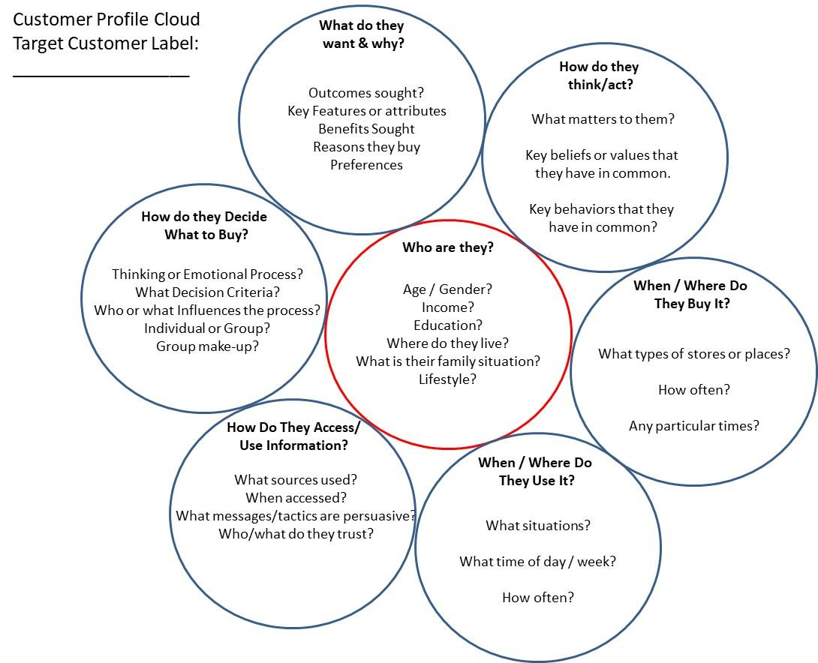

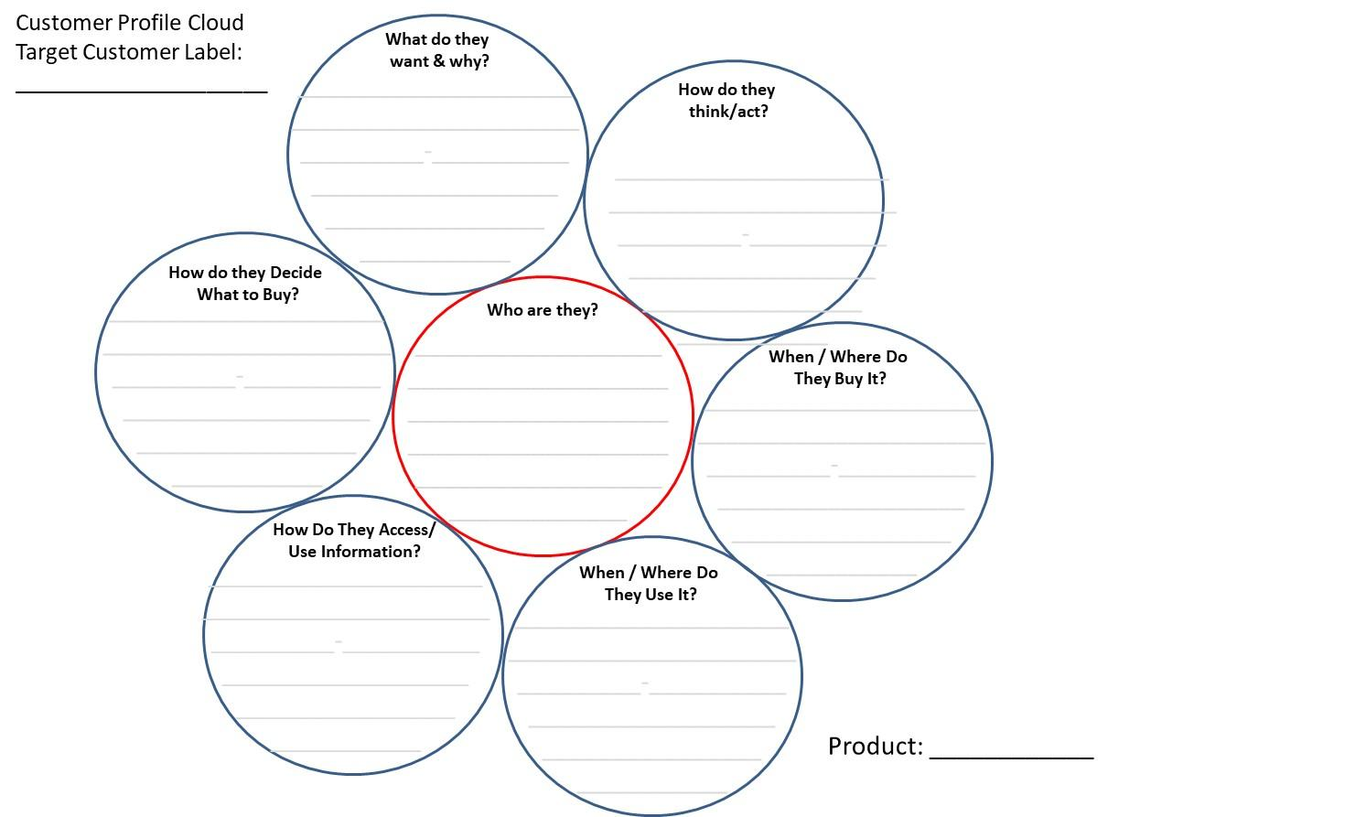
Learning Insight
This task can be done individually or in small groups. Once the students have had about 15 minutes to do this, ask different students or groups to report back on parts of the cloud. Collectively they will have a lot more detail. This detail helps entrepreneurs make key decisions about what to make, where to sell it, and how to attract target customers.

Unit 1 Assignment: Elevator Pitch or Written Product Concept

Develop an elevator pitch (a 2 minute or less presentation) for a new product or write a two or three paragraph description of a new product concept.
Oral Presentation:
In 2 minutes or less, present your idea for a new product concept. Keep in mind that “new” is relative. It ranges from small incremental innovations such as new flavours, sizes, and shapes, to products that do not yet exist in your community or city, or products that are new to the world (very rare). Your presentation should address (in an order that makes sense to you):
- What it is that you have identified as being needed. E.g., my product is ________
- Who it is for? Describe your target customer in about 20 seconds. Who are they, what do they want, and why? When and where do they want that?
- Explain the problem/frustration/pain that you are trying to solve.
  - If possible, provide evidence that the pain is real, important and motivating to your target customer.
- Your solution to the problem, identifying key features, attributes or characteristics of your product and the benefits (value) to your customer.
  - If possible, provide evidence that your target customers perceive that your product is valuable and worth the price you think you will need to charge them.
- What makes your product special or unique – how is it better than what already exists?
- Why should we believe that this is possible?
- Why should we believe that you (or a team your lead) can do this well?

Written Product Concept:
In one page (double spaced) or less, describe your new product concept. Keep in mind that “new” is relative. It ranges from small incremental innovations such as new flavours, sizes, and shapes, to products that do not yet exist in your community or city, or products that are new to the world (very rare). Your writing should be in an active voice (talk directly to your customer to try to persuade them). Your description should address (in an order that makes sense to you).
- What it is that you have identified as being needed? E.g., my product is ________
- Who it is for? Describe your target customer in about 3 sentences. Who are they, what outcome and benefits do they want, and why? When and where do they want that?
- Explain the problem/frustration/pain that you are trying to solve.
      - If possible, provide evidence that the pain is real, important and motivating to your target customer.
- Your solution to the problem, identifying key features, attributes or characteristics of your product and the benefits (value) to your customer.
      - If possible, provide evidence that your target customers perceive that your product is valuable and worth the price you think you will need to charge them.
- What makes your product special or unique – how is it better than what already exists?
- Why should we believe that this is possible?
- Why should we believe that you (or a team your lead) can do this well?

Unit 1 Assignment Assessment:

1. Clarity of product description (overview) 7 6 5 4 3 2 1
2. Clarity of target customer, outcome & benefits sought 7 6 5 4 3 2 1
3. Clarity of target customer problem/frustration/pain & 7 6 5 4 3 2 1
evidence that the pain is real, important and motivating.
4. Clarity of your detailed product description – how your 7 6 5 4 3 2 1
solution creates value for your customer & evidence.
5. Compelling argument that the product is special or unique 7 6 5 4 3 2 1
6. Compelling reasons to believe this is possible/promises true 7 6 5 4 3 2 1
7. Compelling rationale for why your team can do this well. 7 6 5 4 3 2 1

To receive the other 11 entrepreneurship lesson plans, please email Dr. Brock Smith of the University of Victoria (smithb@uvic.ca)

Dr. Brock Smith is a professor of entrepreneurship and marketing, Winspear Scholar, and Entrepreneurship Area Champion at the Peter B. Gustavson School of Business at the University of Victoria. UVic’s entrepreneurship program has earned international awards for pedagogy and many of its graduates are leaders in entrepreneurial communities in British Columbia, Canada, and around the world. Winner of the 1992 Academy of Marketing Science Doctoral Dissertation Award, Dr. Smith has published more than 25 articles in leading management, entrepreneurship, and marketing journals. His research interests focus on entrepreneurial cognition, customer-value creation strategies, and issues at the marketing-entrepreneurship interface. He founded UVic’s Innovation Centre for Entrepreneurs (now the Coast Capital Innovation Centre) and helped found the Vancouver Island Social Innovation Zone. Prior to his academic career, Dr. Smith held a variety of sales and marketing roles with IBM Canada. He owns boutique market research firm that provides opportunities for students to gain market research acumen by working on industry projects.

